

PROJECT REPORT: ASTRONAUT'S ODYSSEY
13.06.2025
─
Phạm Hoàng Tuấn Tú
Phan Hoàng Khang
Nguyễn Quốc Thắng

Table of contents
- OVERVIEW
- GAME RULES AND FEATURES
- SYSTEM ARCHITECTURE AND DESIGN
  - 3.1. Core Engine and State Management (main & gamestate packages)
  - 3.2. Input Handling System (inputs package)
  - 3.3. Entity Design (entities package)
  - 3.4. Level Design and Management (levels package)
  - 3.5. Interactive Object System (objects package)
  - 3.6. User Interface (ui package)
  - 3.7. Utilities and Helpers (utilz package)
- CONCLUSION
- REFERENCES

Overview
This report provides a detailed technical overview of "Astronaut's Odyssey," a 2D side-scrolling platformer developed using Java and the Swing library. The project demonstrates core principles of object-oriented programming, including inheritance, polymorphism, encapsulation, and abstraction, to create a scalable and maintainable game architecture.
This document is structured into several key sections:
- Section I: Game Rules and Features: An introduction to the game's objective, core mechanics, and interactive elements.
- Section II: System Architecture and Design: A deep dive into the technical implementation of the game, broken down by functional packages. This section explains the purpose and design of each class, their interactions, and includes simplified class diagrams to illustrate the system's structure.

Game rules and features
"Astronaut's Odyssey" places the player in the role of an astronaut exploring hostile alien environments. The primary objective is to navigate through a series of levels, survive encounters with alien lifeforms, and overcome environmental hazards.
Core Gameplay Mechanics:
- Player Control: The player character can run left and right, jump to traverse platforms, and perform a melee attack. The physics system incorporates gravity, creating a classic platforming experience.
- Combat: The player must engage with hostile entities, primarily the "Slime" creatures. A successful attack will damage enemies. The player also has a health pool, which depletes upon taking damage from enemies or environmental traps. The game ends if the player's health reaches zero.
- Level Progression: A level is considered complete when all active enemies have been defeated. Upon completion, the player can advance to the next level.
- Interaction: The world is filled with interactive objects. Containers (boxes and barrels) can be destroyed by the player's attack to reveal BatteryItems (potions). These items can be collected to restore health or grant other power-ups. The levels are also populated with static Traps (spikes), which will instantly defeat the player upon contact.

System architecture and design
The game is built upon a modular architecture, with responsibilities cleanly divided into distinct packages. This design promotes code reusability and simplifies maintenance.

3.1. Core Engine and State Management (main & gamestate packages)

The game's execution is managed by a central engine that operates on a Finite State Machine (FSM) pattern. This ensures that the game can only be in one state at a time (e.g., MENU, PLAYING, GUIDE), which organizes game flow and prevents logical conflicts.

: The central class of the entire application. It initializes all managers and game states. Its most critical component is the game loop, implemented in the run() method. This loop intelligently separates game logic updates (Updates Per Second - UPS) from rendering (Frames Per Second - FPS), ensuring that game speed is independent of rendering performance.

: An enum that defines all possible states of the game. It holds a static variable, Gamestate.state, which acts as a global switch, dictating the application's current behavior.

& These form the blueprint for all game states. The interface guarantees that every state will have standard methods like update() and draw(Graphics g), allowing the main Game class to manage them polymorphically.

Class Diagram: Core Engine & State Machine
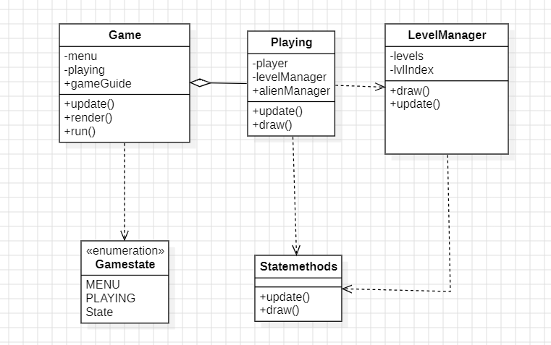

3.2. Input Handling System (inputs package)

The input system is designed as a router. It captures raw keyboard and mouse events and directs them to the currently active game state, which is responsible for interpreting their meaning.

& These classes implement Java's KeyListener and MouseListener interfaces. Their methods contain a switch statement that checks Gamestate.state. Based on the current state, the event is forwarded to the corresponding state object's event handling method (e.g., playing.keyPressed(e)). This decouples input detection from input handling.

3.3. Entity Design (

All dynamic characters in the game are managed by the entities package, built upon a clear inheritance hierarchy.

: An abstract base class that defines common properties for all characters, such as position, dimensions, hitbox, attackBox, health, and an animation state machine (state, aniTick, aniIndex).

: Extends Entity. This class contains all logic specific to the player, including handling user input flags (left, right, jump), managing physics, updating animations, and rendering the character sprite (including a clever sprite-flipping mechanism to handle direction).

& A further extension of the hierarchy for enemies. Alien is an abstract class defining common AI behaviors like patrolling, detecting the player (canSeePlayer), and taking damage. Slime is a concrete implementation with a specific state machine for its IDLE, RUNNING, and ATTACK behaviors.

: A manager class that orchestrates all Slime instances in a level. It is responsible for updating their state, drawing them, and checking for collisions with the player's attacks.

Class Diagram: Entity System

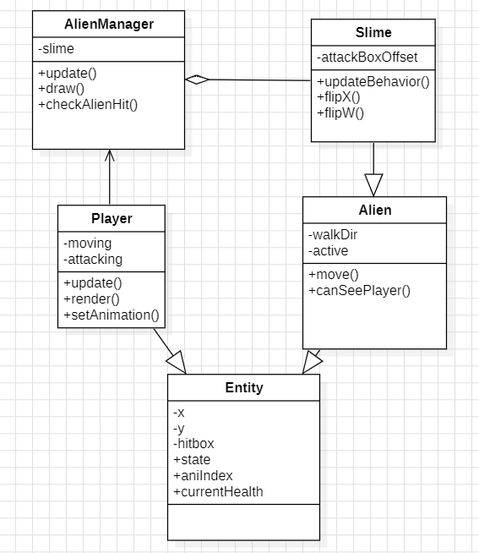

3.4. Level Design and Management (levels package)
The game employs a powerful data-driven approach to level design, using image files as blueprints for game worlds.
- : A data container class. Its constructor takes a BufferedImage and, using helper methods, parses the color data of each pixel to generate the level's structure. The red channel defines the tilemap, the green channel defines enemy placements, and the blue channel defines object placements.
- : The master controller for all levels. It loads all level blueprints from a directory, stores them as Level objects, and is responsible for drawing the current level's tilemap. Its loadNextLevel() method is critical, as it orchestrates the transition by providing the new level's data to the Player, AlienManager, and ObjectManager.

3.5. Interactive Object System (
This package manages all non-character interactive elements, following an inheritance and manager pattern similar to the entity system.
- : An abstract base class for all objects, defining shared properties like position, hitbox, objType, and active status.
- , Concrete classes that extend GameObject. Each adds unique behavior: GameContainer has a breaking animation, BatteryItems has a visual hover effect, and Die1 is a static hazard.
- : Centralizes all object logic. It is responsible for loading objects for a level, updating and drawing them, and, most importantly, handling all player-object interactions. This includes checking for collisions with traps, pickup items, and breakable containers.

3.6. User Interface (
The UI is built on a reusable, component-based architecture.
- Component Classes ( These classes represent the basic building blocks of the UI. They encapsulate their own state (e.g., mouseOver, mousePressed), visuals (loading sprites for different states), and update logic.
- Overlay Classes ( These classes represent full-screen menus. They are composed of the smaller button components. They manage the layout of the UI elements and route mouse events to the appropriate buttons, which then handle their own visual feedback.

3.7. Utilities and Helpers (
This package contains helper classes and data that support the entire project, promoting clean and readable code.
- : A central repository for all "magic numbers" and configuration data. It uses nested static classes to group constants logically (e.g., PlayerConstants, UI.Button), making the code self-documenting and easy to modify.
- : A utility class dedicated to loading all file-based assets (images, levels) from the project's resources. It centralizes file I/O and error handling.
- : A collection of static helper functions for complex or repetitive tasks. This includes the core physics and collision detection logic (CanMoveHere, IsEntityOnFloor) and the level-parsing methods (GetLevelData, GetSlimes).

4. CONCLUSION
"Astronaut's Odyssey" successfully implements a robust and scalable 2D game engine using core object-oriented principles. The modular design, centered around a state machine and manager classes, allows for a clear separation of concerns. This makes the system easy to debug, maintain, and extend with new features, such as additional levels, enemies, or UI screens. The data-driven approach to level design, in particular, provides a flexible workflow for content creation. This project serves as a strong practical demonstration of applying object-oriented design patterns to solve common problems in game development.

5. REFERENCES
- Gamma, E., Helm, R., Johnson, R., & Vlissides, J. (1994). Design Patterns: Elements of Reusable Object-Oriented Software. Addison-Wesley.
- Nystrom, R. (2014). Game Programming Patterns. Genever Benning.
- Java™ Platform, Standard Edition 8 API Specification. Oracle.

